Fort Frances Airport Landing/Parking Fees International Aircraft
Effective: January 1., 2021

-
Landing Fee Calculations Parking Fee Calculations

Minimum Fee - $37.00
<21,000 kgs - GW X $9.05 21-45,000 kgs - GW X $9.05
Plug-ins - $6.70 per day per heater
Type Land Park Beechcraft
BE9L, 99 (5) 45.25 19.60
BE10 20 (6) 54.30 19.60
BE30 (7) 63.35 19.60
BE40, 1900 (8) 72.40 19.60
<4,999 kgs - $12.30/day - $93.6.5/month
5 - 9,999 kgs - $19.60/day - $378.20/month 10-29,000 kgs - $35.10/day - $702.40/month

Type Land Park
. Cessna
C208 (4) 37.00 12.30
C441 (5) 45.25 19.60
C525 (5) 45.25 19.60
C500 (6) 54.30 19.60
C550 (7) 63.35 19.60
DeHavilland
DH2T (3) 37.00 | 12.30
DH6 (6) 54.30 | 19.60
OHS (16) 144.80 | 35.10
DHSC (16) 144.80 | 35.10
DH? (20) 181.00 | 35.10
Falcon
FA10 (9) 81.45 | 19.60
FA20 (15) 135.75 | 35.10
FASO (18) 162.90 | 35.10
FA90 (21) 190.05 | 35.10
Fairchild
SW2 (5) 45.25 | 19.60
SW4 - Merlin (6) 54.30 | 19.60
SW4 (7 63.35 | 19.60
Casa
CS12 8 72.40 | 19.60

C56X (9) 81.45 19.60
C680 (10) 90.50 19.60
Lear

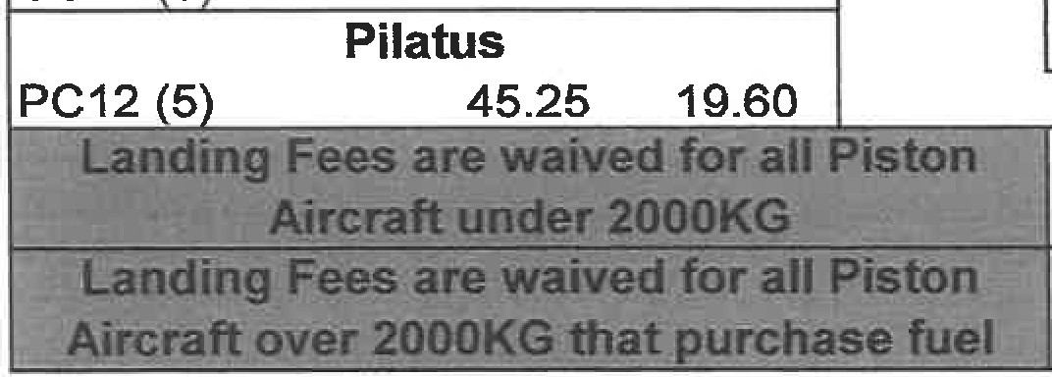
LR23 (6) | 54.30 | 19.60
LR24,25,28,29(7) | 63.35 | 19.60
LR31 (8) | 72.40 | 19.60
LR35 (9) | 81.45 | 19.60
Piaggio
P180 (6) | 54.30 | 19.60
Piper
PAY 1,2 (5) | 45.25 | 19.60
PAY 3,4 (6) | 54.30 | 19.60

Mitsubishi  MU2 (5) 45.25 |  | 19.60
MU30 (8) | 72.40 | 19.60

JS31 7 | Jetstream  63.35 | 19.60
All Models | Piston Aircraft  37.00 | 12.30

